Guido,

Thank you again for assigning me this task. I understand that Credit One is at risk of losing customers due to clients defaulting on their credit cards.

Upon my initial examination of the data I noticed that customers in their 20’s-30’s who hold a university degree predominately held the greatest dollar amount of debt that was defaulted on. Graph 1. Customers with a university level of education also had the greatest number of customers who defaulted when compared to the other categories of education. Graph 2. However, it should be noted that the percentage of customers in their 20’s and 30’s with both graduate and university degrees had a high percentage (34-40%) of customers who did default. Graph 3.



**Percent of each age group by education that defaulted**

**Graph 3**

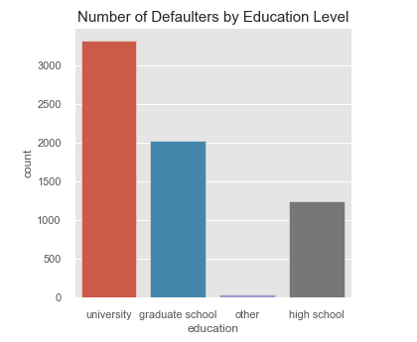

**Graph 2**

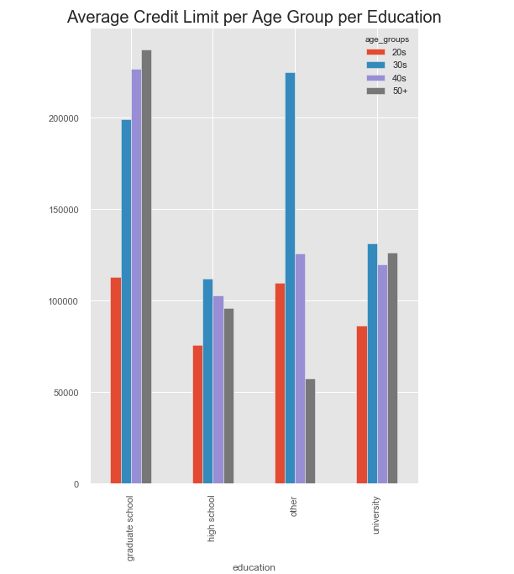

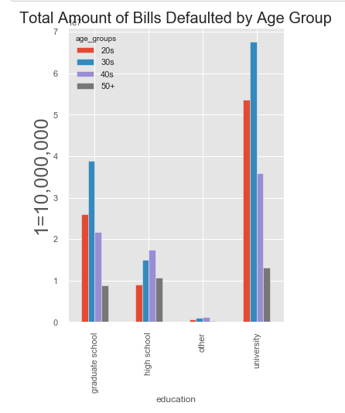

Graph 1

My recommendation using this information would be to look closer at the credit limits given to 20-39-year-old customers with a university and graduate school degrees. A high percentage of these groups are defaulting.

Comments:

* What is the ratio of debt/income? (student loans/homes/new families)
* Do we assume more education=more income?

Secondly, you asked me to if we could predict if a customers’ credit limit given the data I was given. Using my analysis, I concluded that you cannot predict a credit limit given this information. There does not seem to be any pattern based on this data on how much credit was given to your customers.

Some additional data such as income and credit scores may help me to determine this.

Lastly, you asked if I could predict whether a loan would be in default status the next month given this data. Yes, I can predict this with 82% accuracy. The most important factor is the status of the loan the previous month.

If I had more time here are the items I would examine more closely.

* What percentage of debt are the customers using? Does this affect the ability to repay?
* What would the result look like if I eliminated the customers who were not active customers? I.e. those that were not using their cards in the past 6 months.

Thank you.

Sherri Koski